
Year 9

Test 1-Section 1

No resources allowed

Name: ______________________ Class: ______ Time: 10 minutes Total Mark(1):____/16
Total Mark(1+2):____/71

- Write the following in index form
[3 marks]
- $8×8×8×8$

- $f×f×f×f×f×f$

- $3×a×a×b×b$

- Evaluate the following:
[4 marks]
- $5^{2}$

- $7^{1}$

- ${12}^{0}$

- $3^{-2}$

- Simplify the following expressions
[4 marks]
- $3a+6a$

- $12b-7b$

- $4c×5d$

- $\frac{8de}{4e}$

- Match the sketch with the rule
[5 marks]
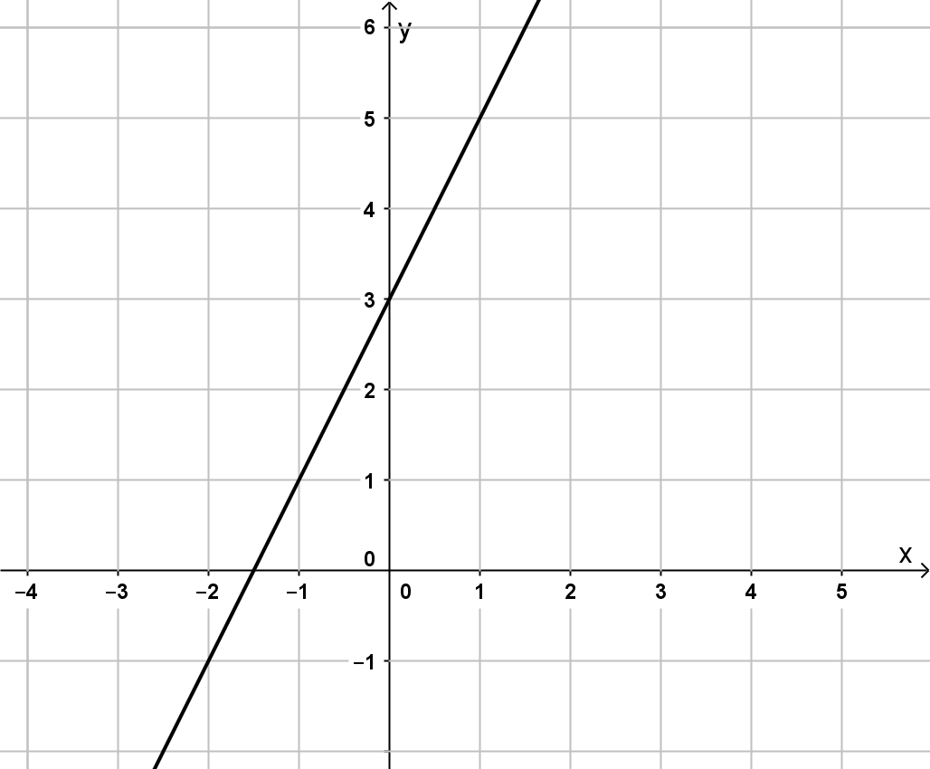 |  | $$y=-1$$
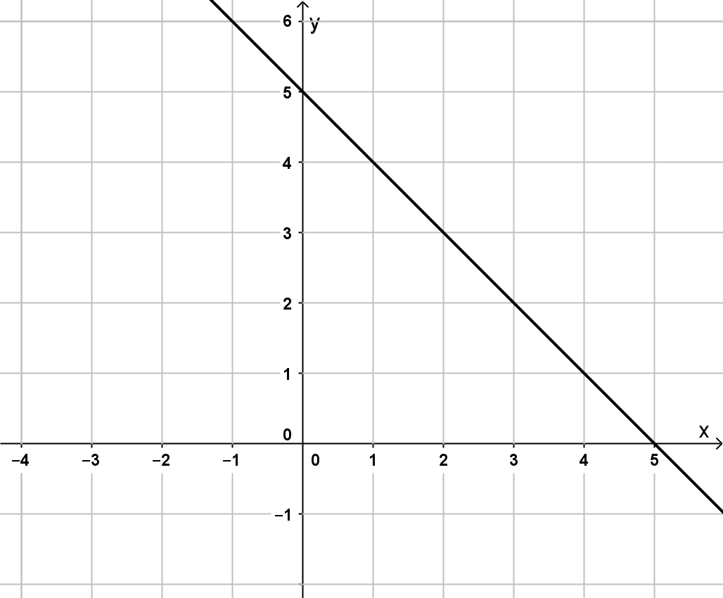 |  | $$y=2x+3$$
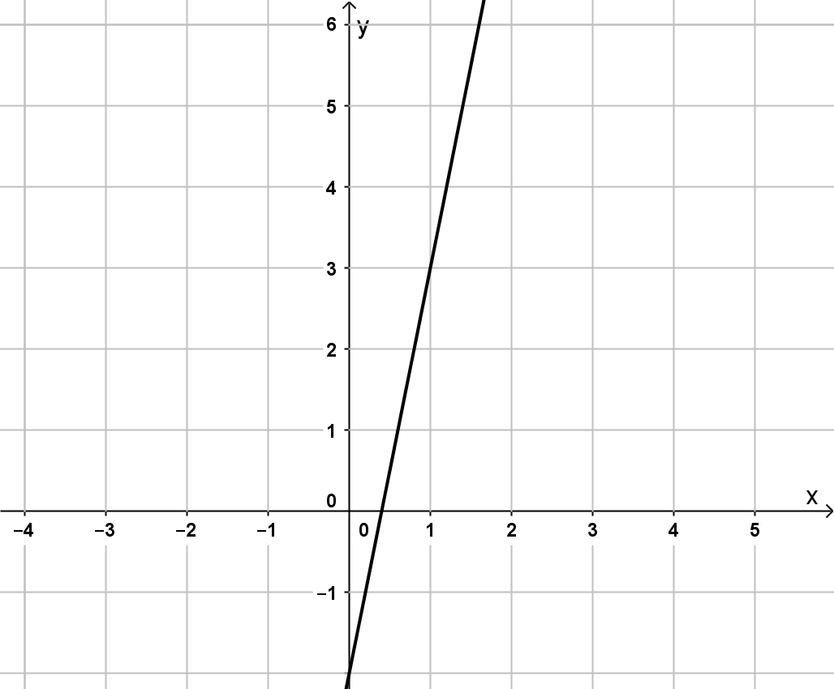 |  | $$x=-1$$
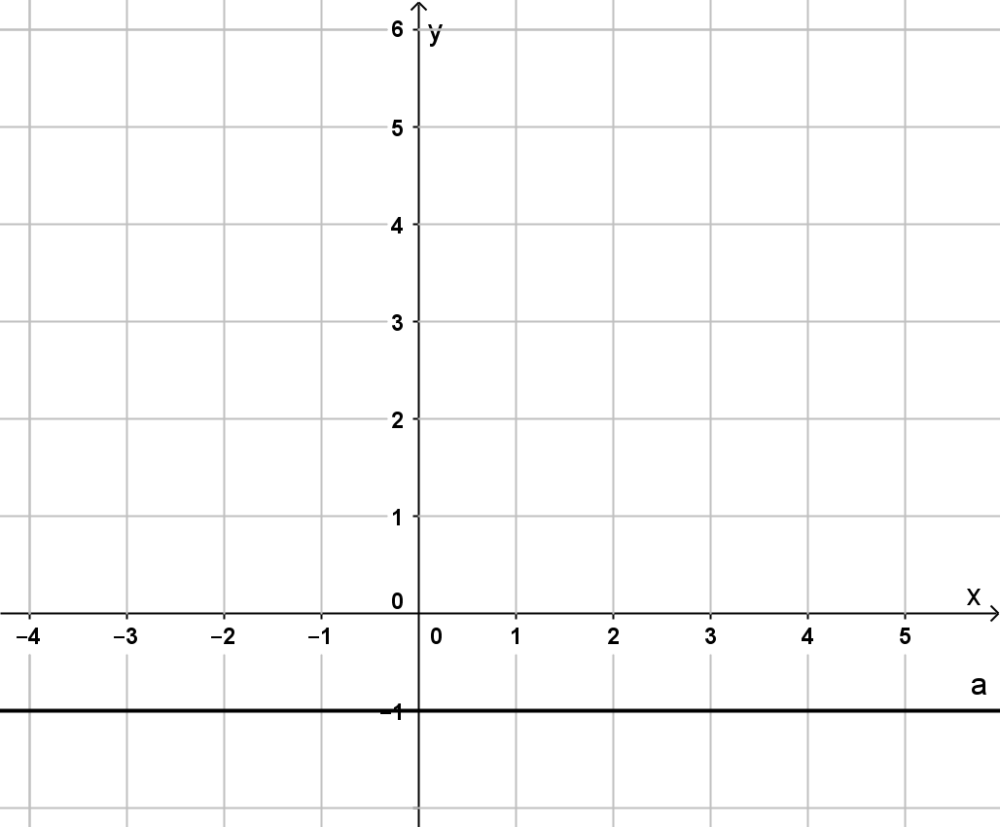 |  | $$y=5-x$$
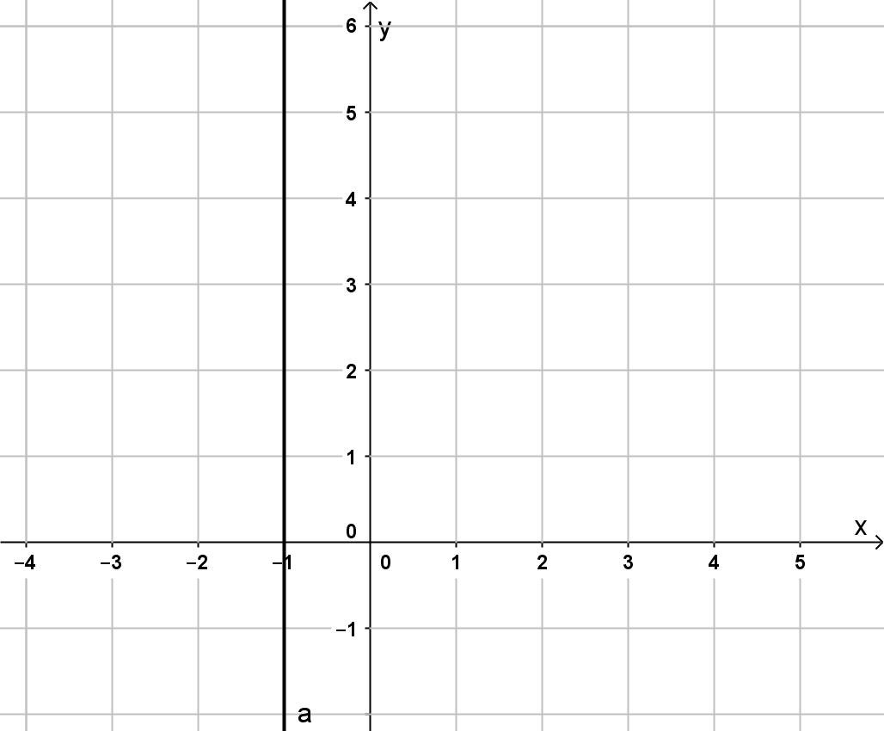 |  | $$Y=5x-2$$


Year 9

Test 1-Section 2

Resources allowed-Scientific calculator/One page of notes

Name: ______________________ Class: ______ Time: 45 minutes Total Mark:_____/55

- Use the Index Laws to simplify each of the following:
[13 marks]
- ${12}^{5}×12^{3}$

- ${10}^{8}×{10}^{-5}$

- $x^{7}×x^{9}$

- $2^{4}×4$

- $3^{9}÷3^{3}$

- $p^{8}÷p^{5}$

- ${9t}^{5}÷{3t}^{-3}$

- ${\left(5^{3}\right)}^{4}$

- ${\left(y^{7}\right)}^{2}$

- ${\left({2k}^{4}\right)}^{3}$

- Write with positive indices:
[3 marks]
- $5^{-3}$

- $\frac{2}{e^{-7}}$

- $\frac{7x^{4}}{y^{-6}z^{3}}$

- Simplify the following expressions:
[6 marks]
- $5c-7c$

- $4a-5+7a$

- $3x^{2}×5x$

- $12p÷4$

- $\frac{30x^{5}y^{6}z}{24x^{3}y^{3}}$

- Expand the following:
[2 marks]
- $5\left(x+3\right)$

- $2y(5-y)$

- By expanding and then collecting like terms simplify
[2 marks]
$$3\left(p+7\right)-5(p-4)$$

- Fully factorise the following expressions
[4 marks]
- $5t+10$

- $9h^{2}-6h$

- Calculate the area of the following shapes
[4 marks]
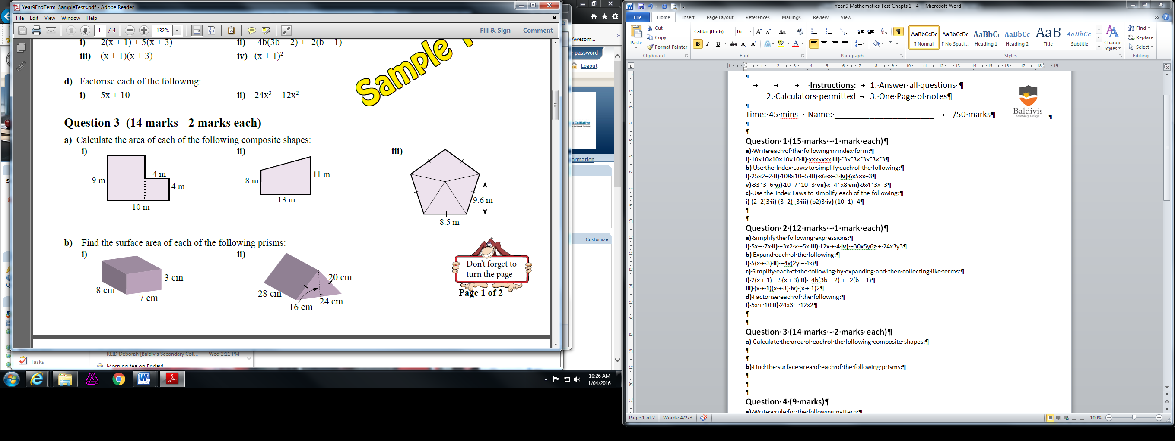



- Calculate the Total surface area of the following shapes
[6 marks]


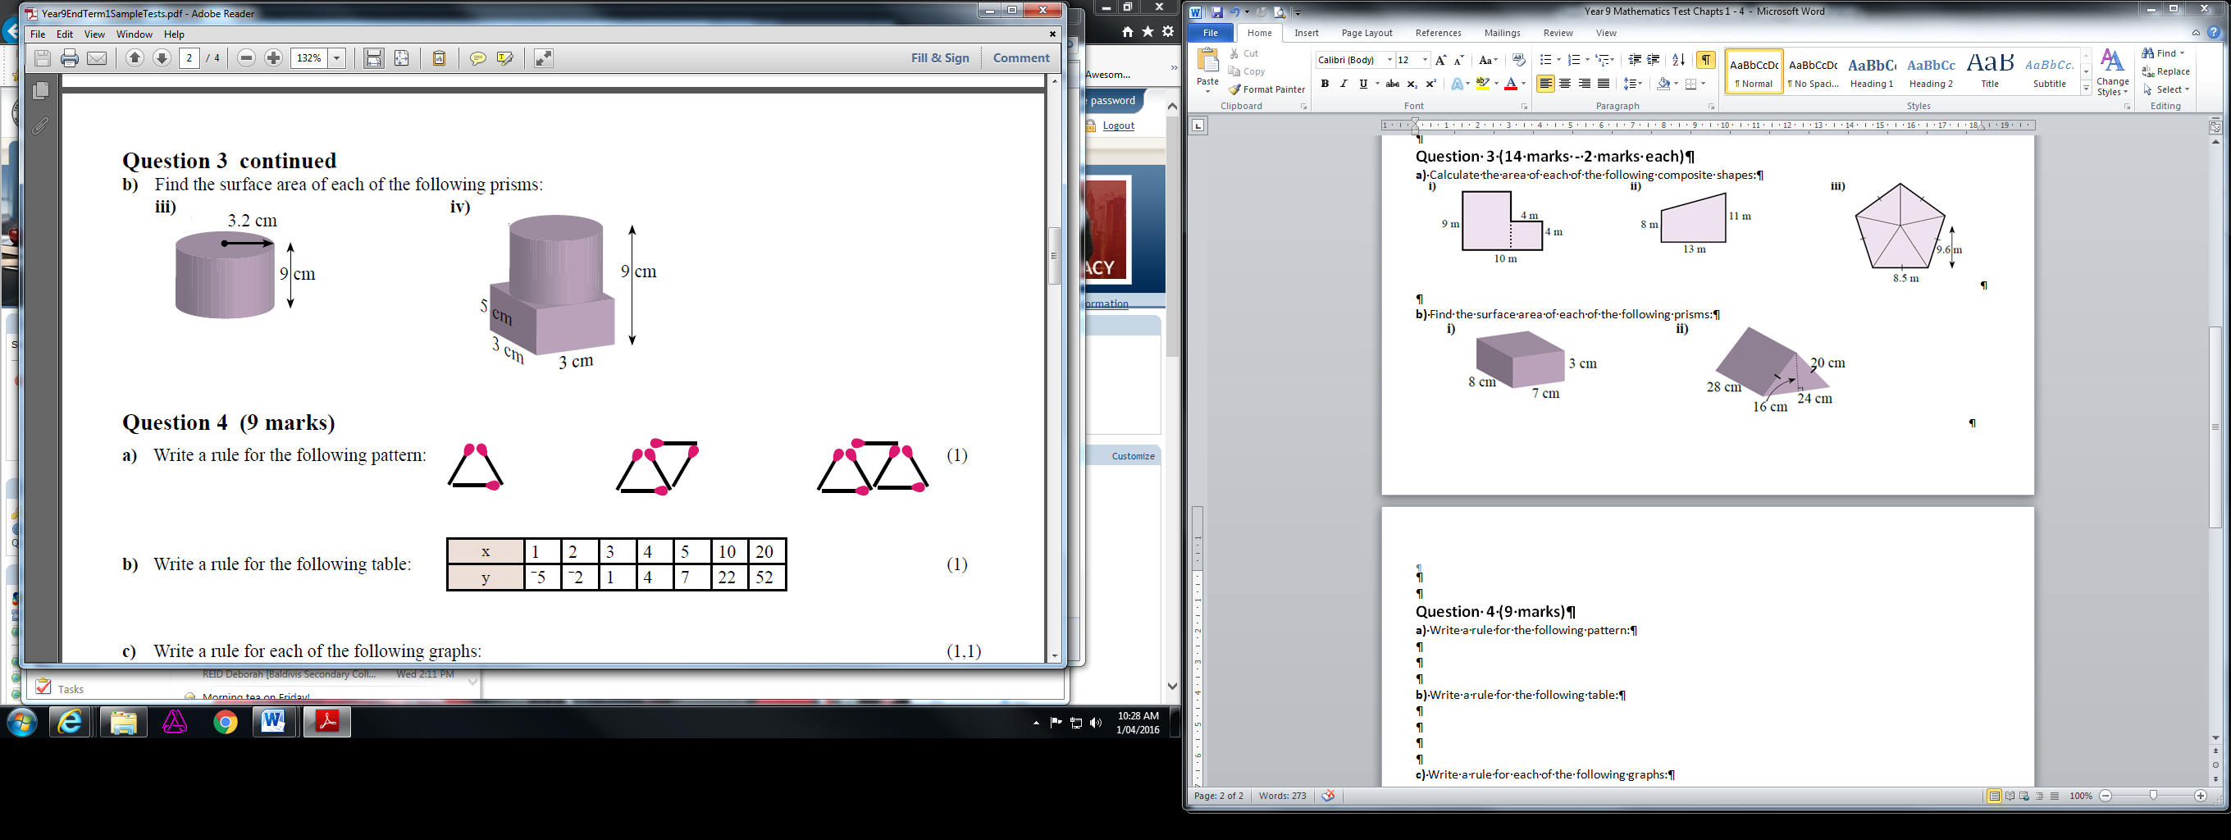
- Write the rule for the following pattern where $s$ in the shape and $m$ is the number of matches.
[1 mark]

- Write the rule for the following tables:
[4 marks]
$$x$$ | 0 | 1 | 2 | 3 | 4
$$y$$ | 5 | 8 | 11 | 14 | 17

$$x$$ | 0 | 1 | 2 | 3 | 4
$$y$$ | 10 | 8 | 6 | 4 | 2

- Write the rule for the following graphs
[4 marks]
- b)
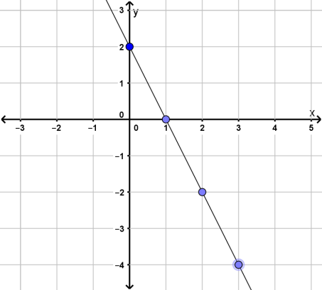
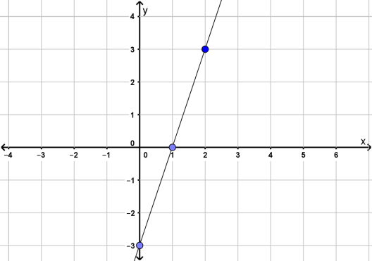

- Sketch the following graphs on the grid below
[6 marks]
- $y=x$
- $y=2x-1$
- $y=-3x+4$
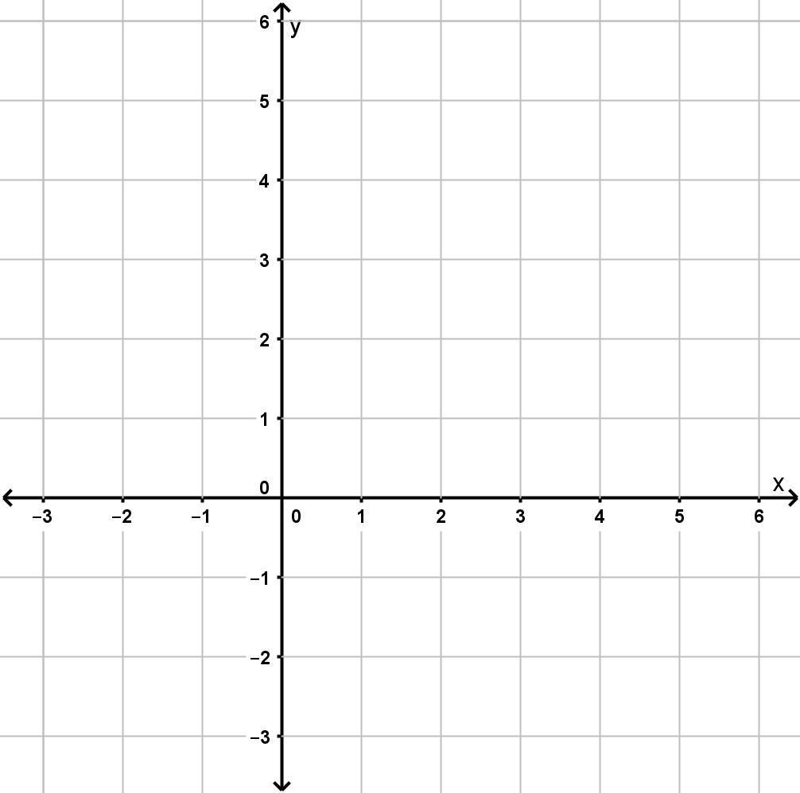

End of Paper.

